***PRACTICAL-3***

***Practical name:- RSA encryption and decryption***

***RSA Encryption***

***DEFINITION:-***  RSA encryption is the process of converting plaintext into ciphertext using a public key. It ensures that only the intended recipient, who holds the private key, can decrypt the message*.*

**RSA Decryption**

***DEFINITION:-*** RSA decryption is the process of reversing RSA encryption using the private key dand the modulus n, such that:

Plaintext (m)=cdmod  n

*TOOLS*:-Online website using*.*

***STEP 1*:-** Go to the search bar and search RSA encryption and decryption.

***STEP 2:-*** Open first website *Dev Glan RSA Encryption Decryption & key generator tool online.*

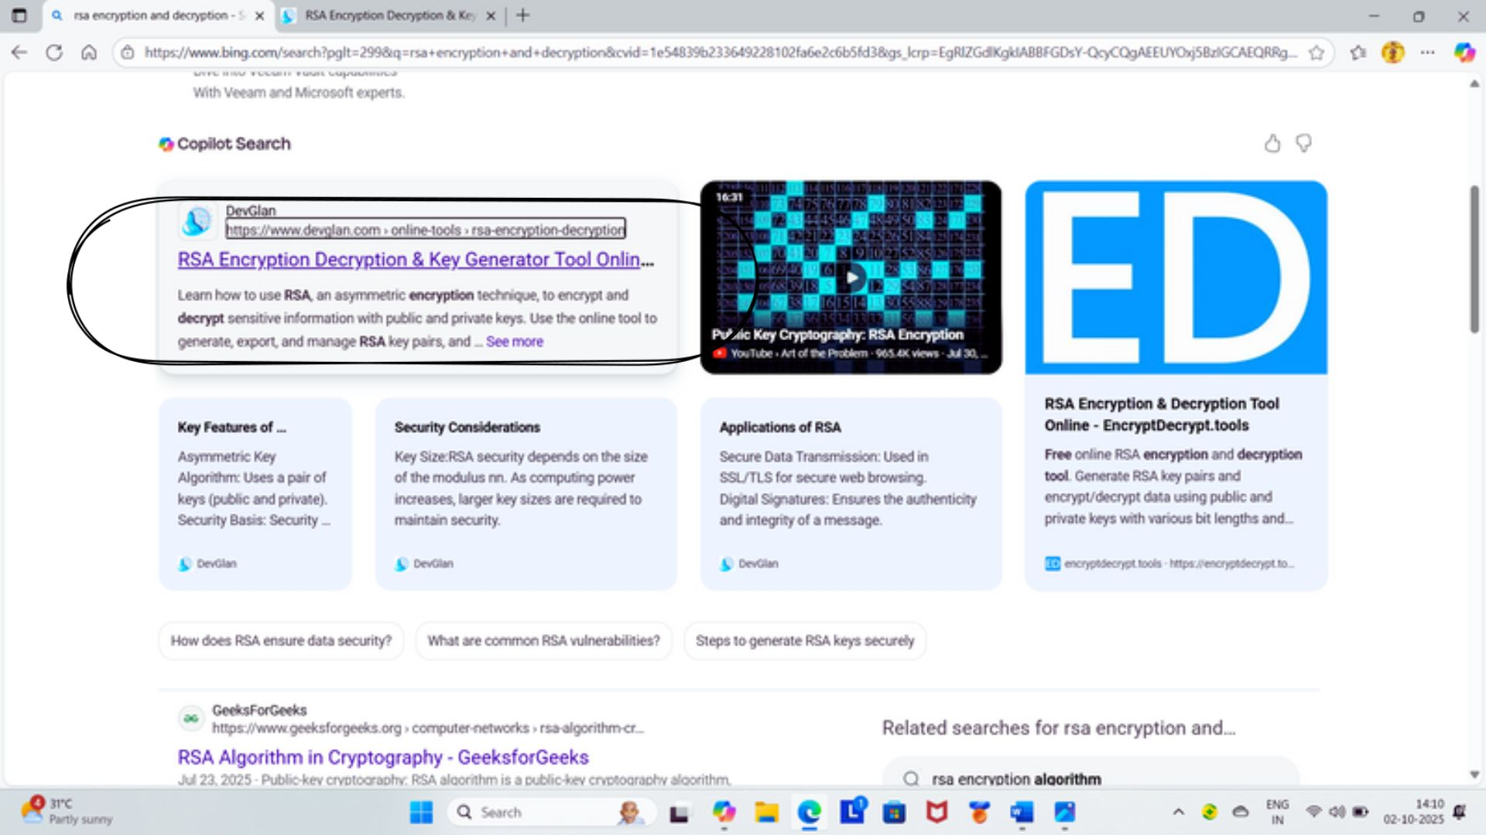

***STEP 3:-*** Click on the generate RSA pair.

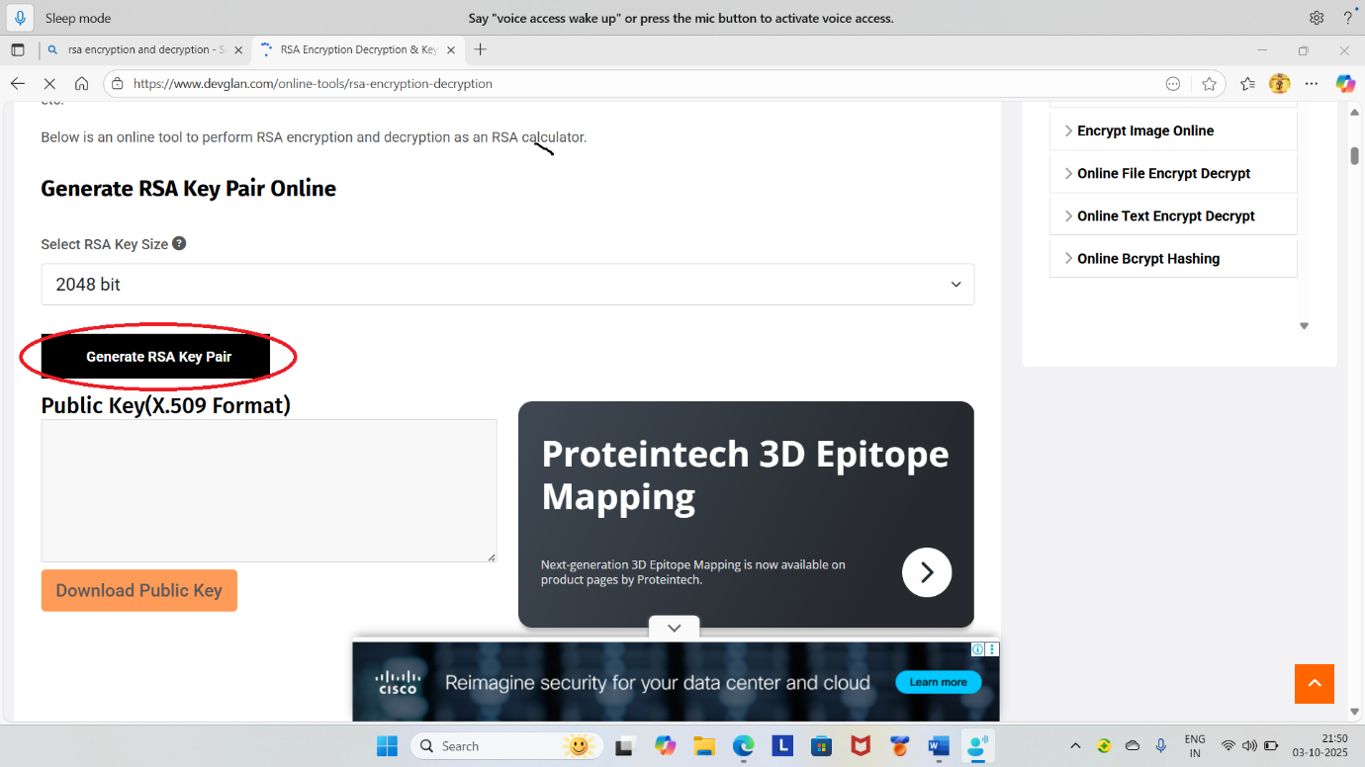

***STEP 4****:-* Enter the text on RSA encryption Box then click on the Encrypt.

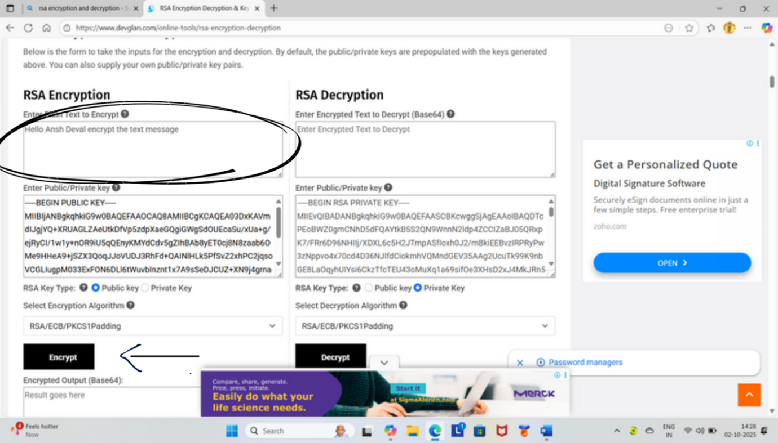

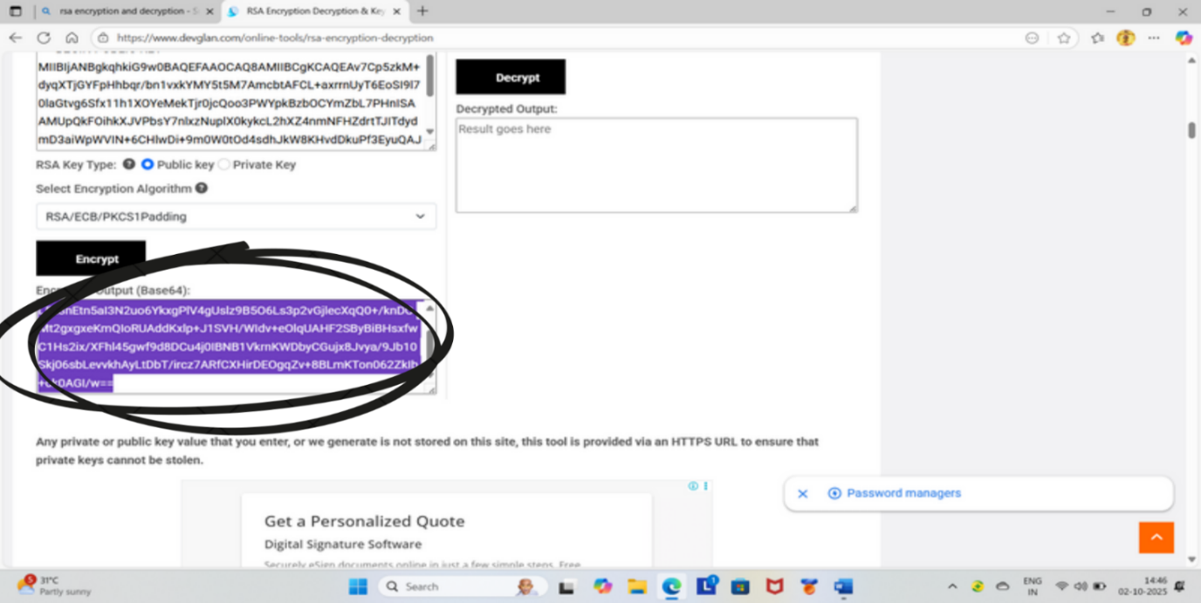

***STEP 5*** *:-* Copy the encrypted output and paste on the RSA Decryption Box.

***STEP 6*** :- Then click on the Decrypt . The you see the encrypted text in the decrypted output.

***STEP 7:-*** I need a bit more context. There isn't a universal, in RSA unless you're following a specific numbered guide or textbook that labels the steps.

